 Mercy Medical Center Division of Nursing 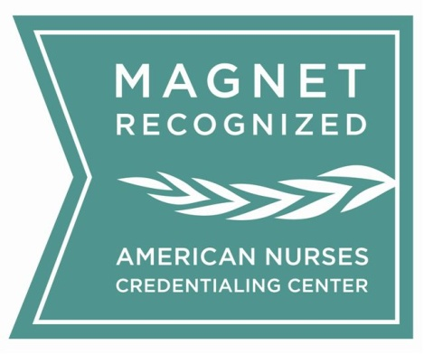
11th EBP/Research Symposium
“Power of Collaboration: Nurses Elevating Healthcare”

March 6, 2026 , 7:30am- 4:30 pm
Loyola University Maryland / McGuire Hall 4TH Floor
4501 N. Charles St. Baltimore, MD 21210
TOPICS

- Artificial Intelligence / Virtual Reality
- Cyber Security
- Shared Governance Organizational Growth
- Johns Hopkins EBP Model: What is new?
- Perinatal Mental Health Issues
- Mother Centered Advocacy in the NICU
- Growing your Virtual Nurse
- Best Practices in Nurse Residency Program
- Application of TSAM Orientation Model in ED
- Power of Collaboration through Research
- Interactive Education Among Stroke Patients
- Pain Reduction Device
- Best Practices in various clinical settings
- Pathway to Publication
- Research/ Translation of Evidence in the War Zone

NOTE: Topics are not limited to above list. It is in progress.
Symposium Program to follow January 2026

*****
CALL FOR ABSTRACT: September 1, 2025 to January 30, 2026 / Acceptance Letter: < January 30, 2026
(Program Contact Information: Dina Krenzischek/ ekrenzis@mdmercy.com / 443-854-2124)
http://mdmercy.com/mercyresearch2026 (Contact Hours 8.0)

Mercy Medical Center is approved as a provider of nursing continuing professional development by the Maryland Nurses Association, an accredited approver by the American Nurses Credentialing Center’s Commission on Accreditation.

